**Intel Unnati Industrial Training**

**Summer Internship 2023**

DESIGN AND IMPLEMENTATION OF AUTOMATED TELLER MACHINE (FSM) CONTROLLER

**TEAM STRIVERS**

Institution:

NITTE MEENAKSHI INSTITUTE OF TECHNOLOGY

**INSTITUTION MENTOR**

**Dr. Rajesh N**

Professor, ECE Dept NMIT

rajesh.n@nmit.ac.in



**Sai Likith P**

**1nt20ec126.sailikhith@nmit.ac.in**

**1NT20EC126**

**Santhosh P**

**1nt20ec133.santhosh@nmit.ac.in**

**1NT20EC133**

**Sudeeksha K**

**1nt20ec151.sudeeksha@nmit.ac.in**

**1NT20EC151**

1. **INTRODUCTION**

An Automated Teller Machine (ATM) is a self-service banking device that allows users to perform various financial transactions, such as cash withdrawals, deposits, balance inquiries, and fund transfers. The design and implementation of an ATM (Finite State Machine) controller project focus on creating a system that facilitates these transactions. The controller operates based on a Finite State Machine (FSM) model, ensuring structured and predictable behaviour. The project involves analysing user requirements, designing the system architecture, developing the software, and conducting thorough testing to ensure functionality and security. By successfully implementing the ATM controller, the project enhances access to financial services and emphasizes the importance of a well-designed system in providing secure and efficient transactions. Ultimately, this project aims to improve the convenience and accessibility of banking services for users.

1. **BLOCK DIAGRAM**
2. **FSM MODEL**

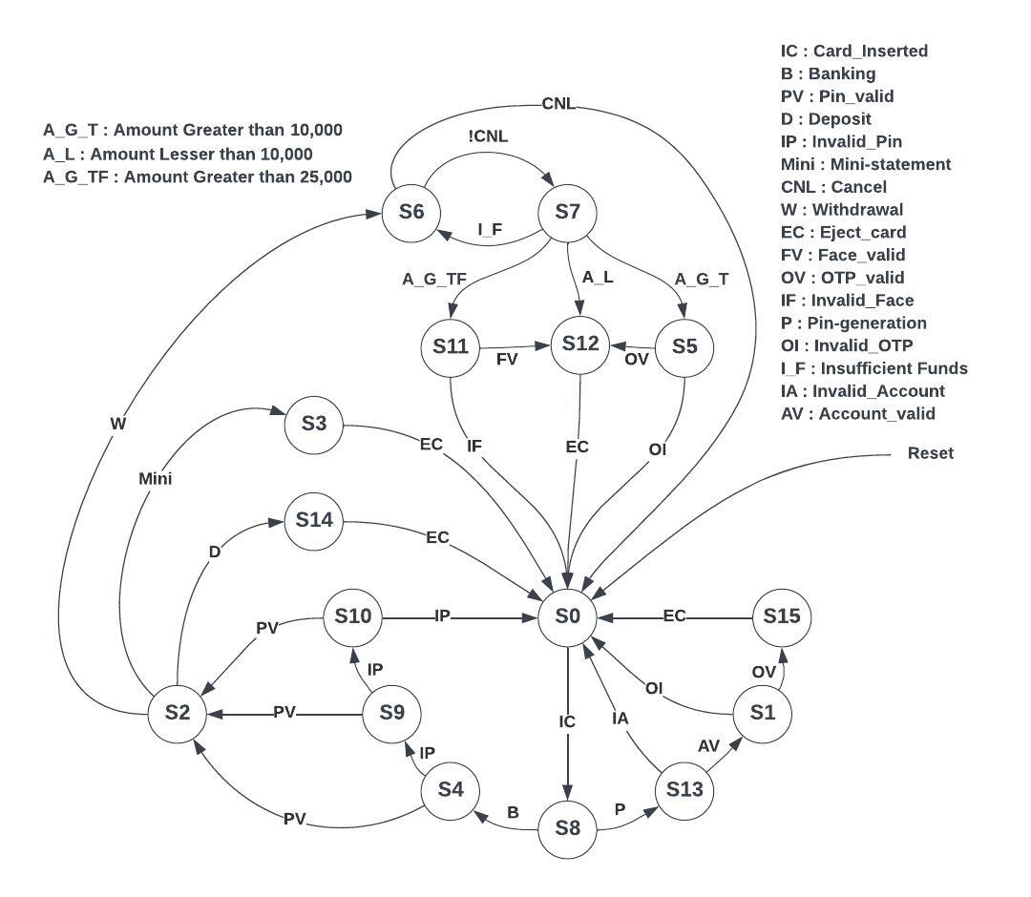



1. **APPROACH USED TO SOLVE THE PROBLEM**

The ATM operates using a Finite State Machine (FSM) with several states and transitions. Initially, the ATM is in an ideal state called S0. When a card is inserted, it moves to state S8, where there are two options: banking and pin generation. If banking is chosen, it transitions to state S4 and prompts for the PIN. If the entered PIN is correct, it moves to state S2, otherwise, it goes to state S9 and requests another PIN attempt. If the correct PIN is entered, it transitions to S2, otherwise, it goes to S10 and allows one more attempt. If the PIN is correct at this point, it goes to S2, otherwise, it goes back to S0, ejecting the card.

In state S2, there is a menu selection with three options: withdrawal, mini statement, and deposit. If withdrawal is selected, it moves to state S6, which presents the options to proceed or cancel the transaction. Choosing to cancel takes it back to S0 and stops the process. Opting to proceed leads to S7, where funds are checked. If there are insufficient funds, it returns to S6. If there are sufficient funds and the chosen amount is greater than 25,000, it moves to S11 to perform face validation. If face validation fails, it goes back to S0. If it passes, it transitions to S12, dispenses cash, and returns to S0 for card ejection. If the chosen amount is between 10,000 and 25,000, it goes to OTP validation. If the OTP is valid, it proceeds to S12, dispenses cash, and goes back to S0. If the OTP is invalid, the process stops and returns to S0.

For amounts less than 10,000, it directly moves to S12 and dispenses cash. In the mini statement option, S2 prints the receipt and then returns to S0 to eject the card. In the deposit option, it transitions from S2 to S14, where cash is deposited and counted. If the deposit is successful, it returns to S0. Additionally, there is an extra feature of pin generation. In S13, it validates the account. If the account is invalid, it goes back to S0. If the account number is valid, it moves to S1 for OTP validation and then to S15 for successful pin generation. If the OTP is invalid, it returns to S0.

1. **WORKING METHODOLOGY**

The Finite State Machine (FSM) is a fundamental concept in digital design, consisting of various states and transitions. In this particular FSM, there are two combinational logic blocks and two sequential blocks.

The first combinational logic block, enclosed in an "always" block, handles the next state logic. It determines the next state based on the current state and input conditions.

The sequential blocks are where the state transitions and output logic occur. The first sequential block triggers the state transitions at the positive edge of the clock, causing the FSM to move from one state to another based on specific conditions or events.

The second combinational logic block is responsible for performing the necessary operations required by the FSM, such as calculations or operations.

The second sequential block deals with the output logic, producing the desired outputs based on the current state and input conditions.

Then database is created to store account details, bank balance, OTP, pins, biometric details (face: digital data). Once this Verilog code is written, it undergoes through stages: analysis and elaboration, synthesis and fitter. These stages involve examining the code for correctness, generating a circuit representation, performing placement and routing to determine the physical layout, and generating a report detailing the results.

Power and timing analysis is conducted to ensure the design meets power consumption and timing requirements. The RTL viewer and Tech map viewer are compared to verify the correctness of the synthesized design.

Finally, the code is implemented on the DE1-SoC kit, a virtual FPGA kit provided by Intel. The kit's outputs are then verified against test cases in the testbench using RTL simulation waveforms, ensuring the FSM operates as intended.

**6. CODE AND TEST BENCH**



**7. VIDEO OF ENTIRE WORK**

[**https://drive.google.com/file/d/1dskdN7A6Dyv1Ilryszm3Pebs4ae4vDjF/view?usp=drive_link**](https://drive.google.com/file/d/1dskdN7A6Dyv1Ilryszm3Pebs4ae4vDjF/view?usp=drive_link)

**8. RESULTS AND SUMMARIZATION**

**8.1 Waveforms**

Click here to view code and testbench

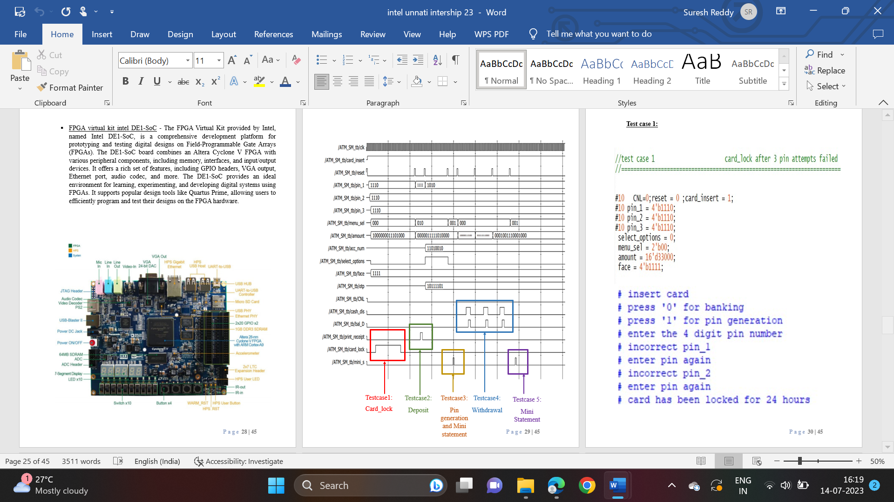

* 1. **Test Cases**
* **Test case 1 – Card lock after 3 attempts**
* **Test case 2 – Deposit**









* **Test case 3 – Pin generation**







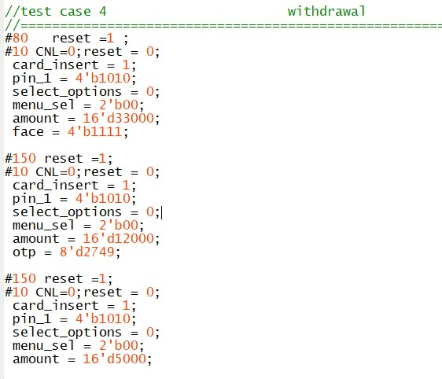

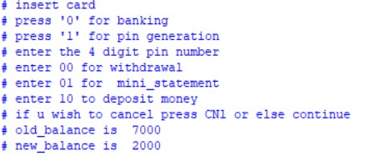

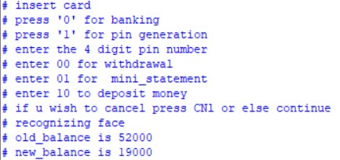

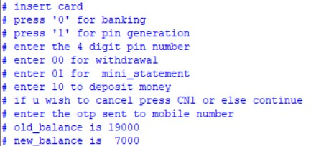

* **Test case 4 – Withdrawal**
* **Test case 5 – Mini statement (recent 5 transactions)**

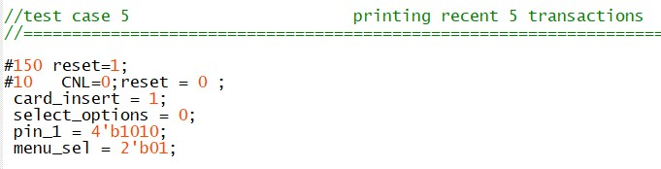

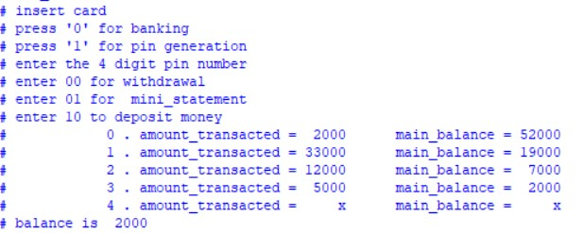

|  |  |
| --- | --- |
| Power Analyzer Status | Successful - Fri Jul 14 16:32:56 2023 |
| Quartus Prime Version | 18.1.0 Build 625 09/12/2018 SJ Lite Edition |
| Revision Name | ATM_FSM |
| Top-level Entity Name | ATM_FSM |
| Family | Cyclone V |
| Device | 5CSEMA5F31C6 |
| Power Models | Final |
| Total Thermal Power Dissipation | 423.25 mW |
| Core Dynamic Thermal Power Dissipation | 0.00 mW |
| Core Static Thermal Power Dissipation | 411.24 mW |
| I/O Thermal Power Dissipation | 12.00 mW |
| Power Estimation Confidence | Low: user provided insufficient toggle rate data |

1

**8.3 Power Analysis Report**

**8.4 Fitter Report**

|  |  |
| --- | --- |
| Fitter Status | Successful - Fri Jul 14 16:30:44 2023 |
| Quartus Prime Version | 18.1.0 Build 625 09/12/2018 SJ Lite Edition |
| Revision Name | ATM_FSM |
| Top-level Entity Name | ATM_FSM |
| Family | Cyclone V |
| Device | 5CSEMA5F31C6 |
| Timing Models | Final |
| Logic utilization (in ALMs) | 443 / 32,070 ( 1 % ) |
| Total registers | 21 |
| Total pins | 60 / 457 ( 13 % ) |
| Total virtual pins | 0 |
| Total block memory bits | 0 / 4,065,280 ( 0 % ) |
| Total RAM Blocks | 0 / 397 ( 0 % ) |
| Total DSP Blocks | 0 / 87 ( 0 % ) |
| Total HSSI RX PCSs | 0 |
| Total HSSI PMA RX Deserializers | 0 |
| Total HSSI TX PCSs | 0 |
| Total HSSI PMA TX Serializers | 0 |
| Total PLLs | 0 / 6 ( 0 % ) |
| Total DLLs | 0 / 4 ( 0 % ) |

1

**8.5 RTL Layout 8.6 Post Mapping Layout**

 

**9. GitHub LINK AND SCREENSHOT**

<https://github.com/SaiLikithP/intelunnati_strivers>

**10. CONCLUSION**

The ATM controller enhances user interaction with memory, increasing security and facilitating transactions. It aids in understanding Finite State Machines and system architecture design. The process of developing a State Machine diagram and conducting system-level analysis is familiarized. The ATM block diagram is examined, and the corresponding Mealy Machine State diagram is analysed. The FSM is implemented in Verilog HDL and verified for various scenarios. Simulation results are validated against appropriate test cases. The code is implemented on the DE1-SoC kit, and the kit's outputs are verified using test cases in the test bench through RTL simulation waveforms. This ensures the FSM operates as intended.

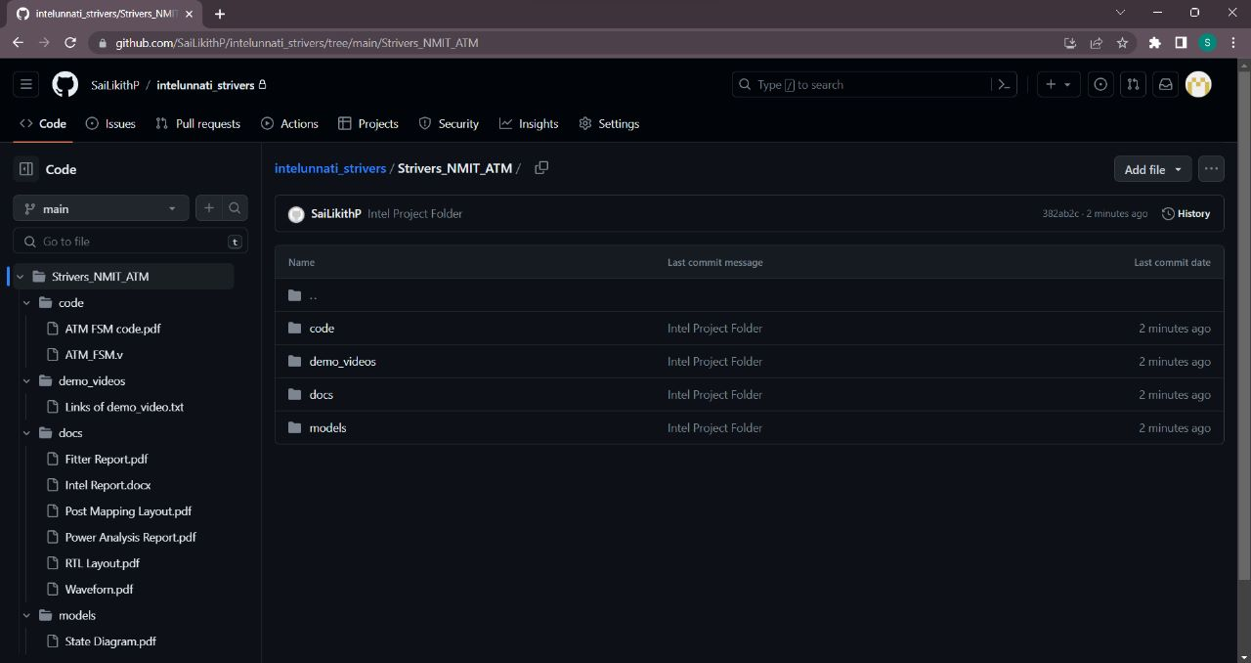

**(Click on the icons to view)**